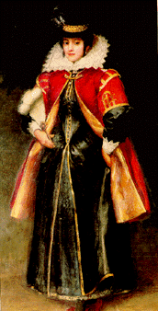
Pocahontas
Essay Question

You are writing an American history book for elementary school students. You have come to the section on Jamestown. What will you say? Be complete. Write at least five paragraphs. You may use your handouts.

You might want to include some of these topics:

Powhatan Indian culture John Rolfe
Chief Powhatan Pocahontas
Expectations of the colonists Food
John Smith Others?

Pocahontas
Essay Question

You are writing an American history book for elementary school students. You have come to the section on Jamestown. What will you say? Be complete. Write at least five paragraphs. You may use your handouts.

You might want to include some of these topics:

Powhatan Indian culture John Rolfe
Chief Powhatan Pocahontas
Expectations of the colonists Food
John Smith Others?

